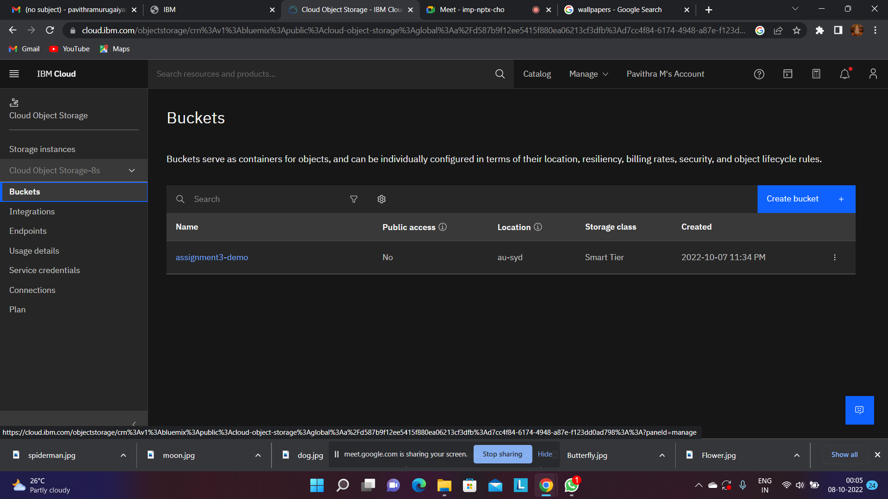

1.Create a bucket in IBM object storage